Replacement Value

Intro

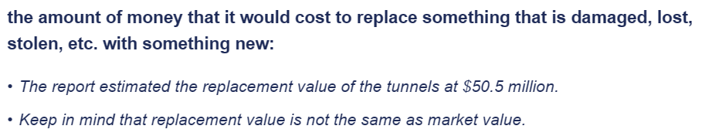

Ref

Intro

[Replacement value - Wikipedia](https://en.wikipedia.org/wiki/Replacement_value)

Definition in Cambridge Dictionary.

[REPLACEMENT VALUE | English meaning - Cambridge Dictionary](https://dictionary.cambridge.org/dictionary/english/replacement-value)